**Lab 4**

**R. Harini**

**18BCE1010**

**Code:**

install.packages("corrplot")

library(corrplot)

dataset=quakes

**#Marginal Histogram/Boxplot**

library(ggplot2)

install.packages("ggExtra")

library(ggExtra)

theme_set(theme_bw())

dataset_select=dataset[dataset$lat<(-20) & dataset$long>180,]

g=ggplot(dataset, aes(lat, long))+geom_count()+geom_smooth(method="lm", se=F)

ggMarginal(g, type="histogram", fill="transparent")

ggMarginal(g, type="boxplot", fill="transparent")

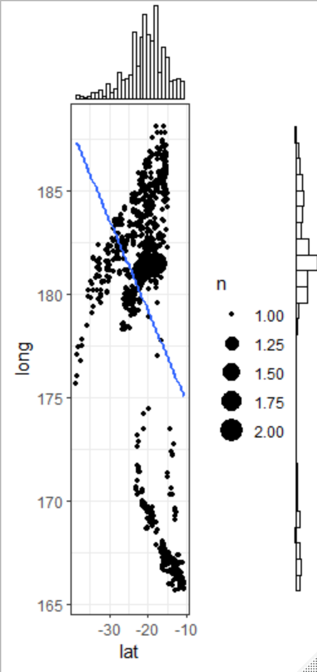 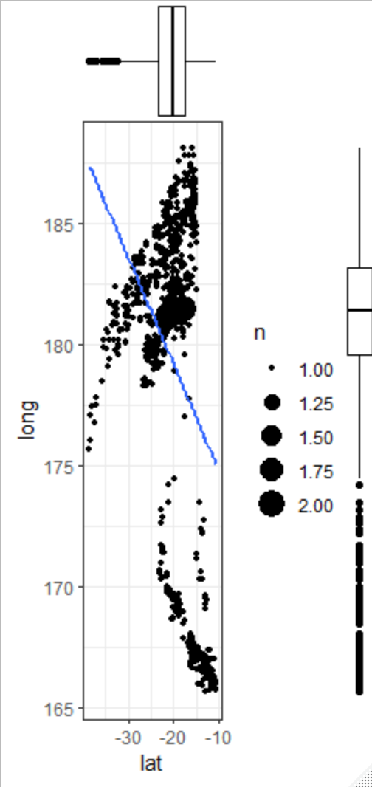

**#Correlogram**

install.packages("ggcorrplot")

library(ggcorrplot)

corr=round(cor(dataset),1)

ggcorrplot(corr, hc.order = TRUE, type="lower",

lab=TRUE, lab_size=3,

method="circle",

colors=c("red", "white", "green"),

title="Correlogram of quakes",

ggtheme=theme_bw())

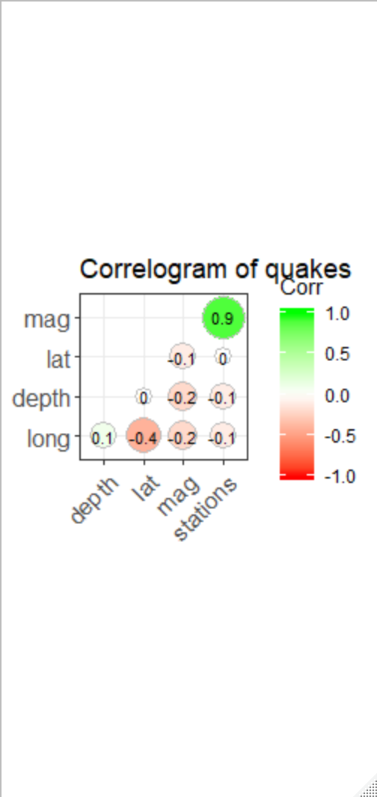

**#Diverging bars**

dataset$'name'=rownames(dataset)

dataset$lat_z=round((dataset$lat-mean(dataset$lat))/sd(dataset$lat),2)

dataset$lat_type=ifelse(dataset$lat<(-20), "below", "above")

dataset=dataset[order(dataset$lat_z),]

dataset$name=factor(dataset$name, levels = dataset$name)

ggplot(dataset, aes(x=name, y=lat_z, label=lat_z))+

geom_bar(stat="identity", aes(fill=lat_type), width=.5)+

scale_fill_manual(name="Quakes", labels=c("Above Average", "Below Average"),

values=c("above"="#00ba38", "below"="#f8766d"))+

labs(subtitle="Normalised Latitude from 'quakes'", title="Diverging Bars")+coord_flip()

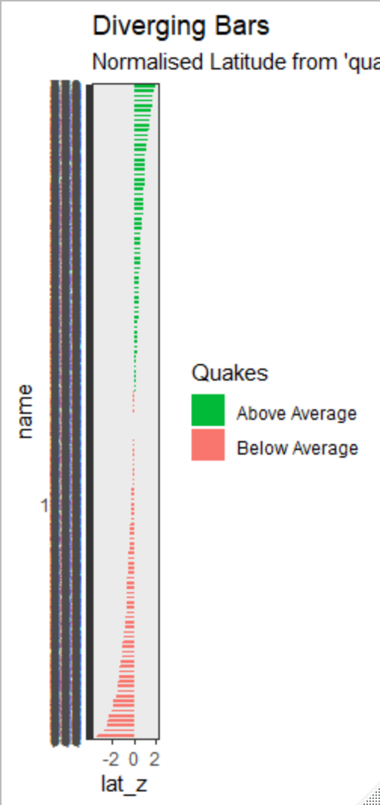

**#Diverging lollipop**

ggplot(dataset, aes(x=name, y=lat_z, label=lat_z))+

geom_point(stat="identity", fill="black", size=6)+

geom_segment(aes(y=0, x=name, yend=lat_z, xend=name), color="black")+

geom_text(color="white", size=2)+

labs(title="Diverging Lollipop Chart", subtitle="Normalised Latitudes from Quakes: Lollipop")+

ylim(-2.5,2.5)+coord_flip()

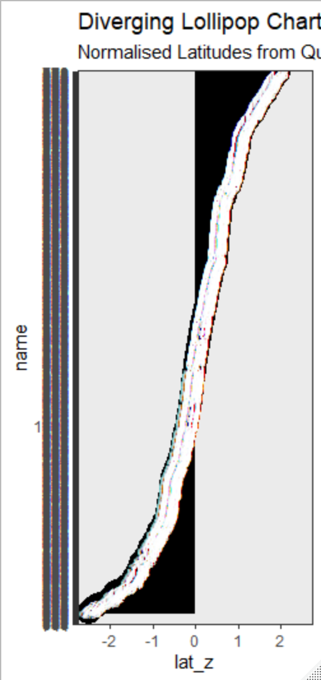 **Due to 1000 Values present in the dataset, the graph looks different than regular diverging Lollipop chart.**

**#Diverging Dot plot**

ggplot(dataset, aes(x=name, y=lat_z, label=lat_z)) +

geom_point(stat='identity', aes(col=lat_type), size=6) +

scale_color_manual(name="Latitude",

labels = c("Above Average", "Below Average"),

values = c("above"="#00ba38", "below"="#f8766d")) +

geom_text(color="white", size=2) +

labs(title="Diverging Dot Plot",

subtitle="Normalized Latitude from 'quakes': Dotplot") +

ylim(-2.5, 2.5) +

coord_flip()

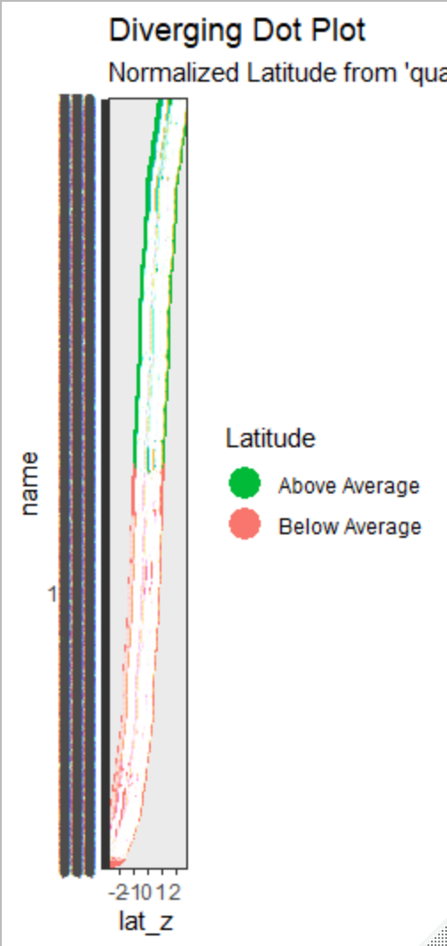 **Due to 1000 Values present in the dataset, the graph looks different than regular diverging Dot plot.**

**#Area Chart**

install.packages("quantmod")

library(quantmod)

economics$returns_perc <- c(0, diff(economics$psavert)/economics$psavert[-length(economics$psavert)])

brks <- economics$date[seq(1, length(economics$date), 12)]

lbls <- lubridate::year(economics$date[seq(1, length(economics$date), 12)])

ggplot(economics[1:100, ], aes(date, returns_perc)) +

geom_area() +

scale_x_date(breaks=brks, labels=lbls) +

theme(axis.text.x = element_text(angle=90)) +

labs(title="Area Chart",

subtitle = "Perc Returns for Personal Savings",

y="% Returns for Personal savings",

caption="Source: economics")

